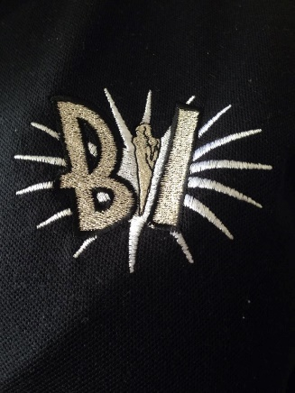

Sponsorship Form for Black Ice
On Saturday 25th March, Black Ice are holding a Sponsored Cheer-a-thon. This event is to raise funds to buy new costumes and new equipment for the cheerleaders. The girls will be tumbling nonstop for 1 hour!! We’ll share videos and photos on social media.
Please give this form to parents, grandparents, family, neighbours and friends and ask them to sponsor you!
Sponsor’s Name | Address | Email/Tel | Sponsorship Amount (£) | UK taxpayer? Y/N

